Checklist for Pump System

Costumer data
Company Name
Contact person
Company address
Country
Phone |  |  |  |  |  |  |  |  |  |  | Fax
Email |  |  |  |  |  |  |  |  |  |  | www
Location of the Pump System
Nearest Town, Country
Latitude |  |  |  |  |  |  | Longitude
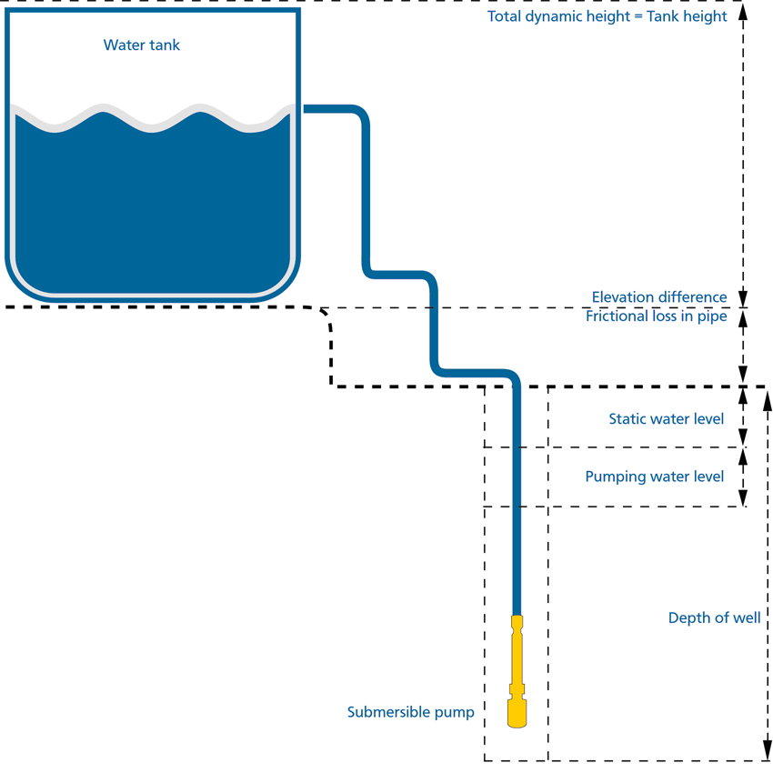

Well
Static water level [m]
Water pumping level [m] |  |  |  |  |  |  |  |  |  | at [m³/h]
Well diameter [inch]
Water quality data
Others
Tank height [m]
Tank volume [m³]
Volume of water required a day [m³]
Horizontal distance between well and tank [m]
Piping size | Total length [m]
 | Diameter [inch]
Deviation North/South direction |  |  | North |  |  |  |  |  |  |  |  |  |  |  |  |  |  |  | South
Watermeter required |  |  | Yes |  |  |  |  |  |  |  |  |  |  |  |  |  |  |  | No
Well head offer |  |  | Yes |  |  |  |  |  |  |  |  |  |  |  |  |  |  |  | No
Support structure offer |  |  | Ground SGM |  |  |  |  |  |  |  |  |  |  |  |  |  |  |  | No
Piping offer |  |  | Yes |  |  |  |  |  |  |  |  |  |  |  |  |  |  |  | No
Information on utilization of the system |  |  | Min. water output of a certain month (month)
 |  |  | Optimization all year round
Intended use of water |  |  | Min. Drinking water
 |  |  | Field irrigation
Information on utilization of the system
Optimization all year round |  |  |  | Yes |  |  |  |  |  |  |  |  |  | No
Optimization for a period from month: |  |  |  |  |  |  |  |  |  |  |  | to month:

